Terraform Task-01

Overall Task Title
Terraform Installation, Template Execution, and Jenkins Integration
Overall Task Objective
The objective of this task is to install Terraform on a local PC, execute basic Terraform templates, understand core Terraform commands (terraform init, terraform plan, terraform apply) and Terraform providers, and integrate a sample Terraform template with Jenkins to automate infrastructure execution using a CI/CD pipeline.
Overall Task Prerequisites
- Windows or Linux operating system
- Internet connection
- Administrator access on the system
- Terraform installed and added to system PATH
- Visual Studio Code (optional, for editing Terraform files)
- Jenkins installed and running
- Git installed on Jenkins server
- GitHub account and repository access
- Jenkins Pipeline and Terraform plugins installed

Task Title
Install and Verify Terraform on Windows pc
Objective
To download, install, configure, and verify Terraform on a Windows machine and successfully run basic Terraform commands (terraform -v, terraform init, terraform validate).
Prerequisites
- Windows OS (64-bit recommended)
- Internet connection
- Administrator access on the system
- Command-line tool (Git Bash / CMD / PowerShell)
Step-by-Step Implementation
Step 1: Download Terraform Binary
- Open a web browser.
- Navigate to the Terraform official website:
- https://developer.hashicorp.com/terraform/install/windows
- Select Windows from the Operating Systems list.
- Download the AMD64 (64-bit) Terraform binary ZIP file.
Step 2: Extract Terraform Binary
- Extract the downloaded ZIP file.
- You will see the following files:
  - terraform.exe
  - LICENSE
- Copy terraform.exe.
Step 3: Create Terraform Directory
- Go to Local Disk (C:)
- Create a folder named:
- C:\Terraform
- Paste terraform.exe inside this folder.
Step 4: Add Terraform to System PATH
- Press Win + R
- Type:
- sysdm.cpl
- Click OK
- Go to the Advanced tab
- Click Environment Variables
- Under System variables, select Path
- Click Edit
- Click New
- Add:
- C:\Terraform
- Click OK → OK → OK
Step 5: Verify Terraform Installation
- Open Git Bash or Command Prompt
- Run the command:
- terraform -v
- Output confirms Terraform installation:
- Terraform v1.14.3
on windows_amd64
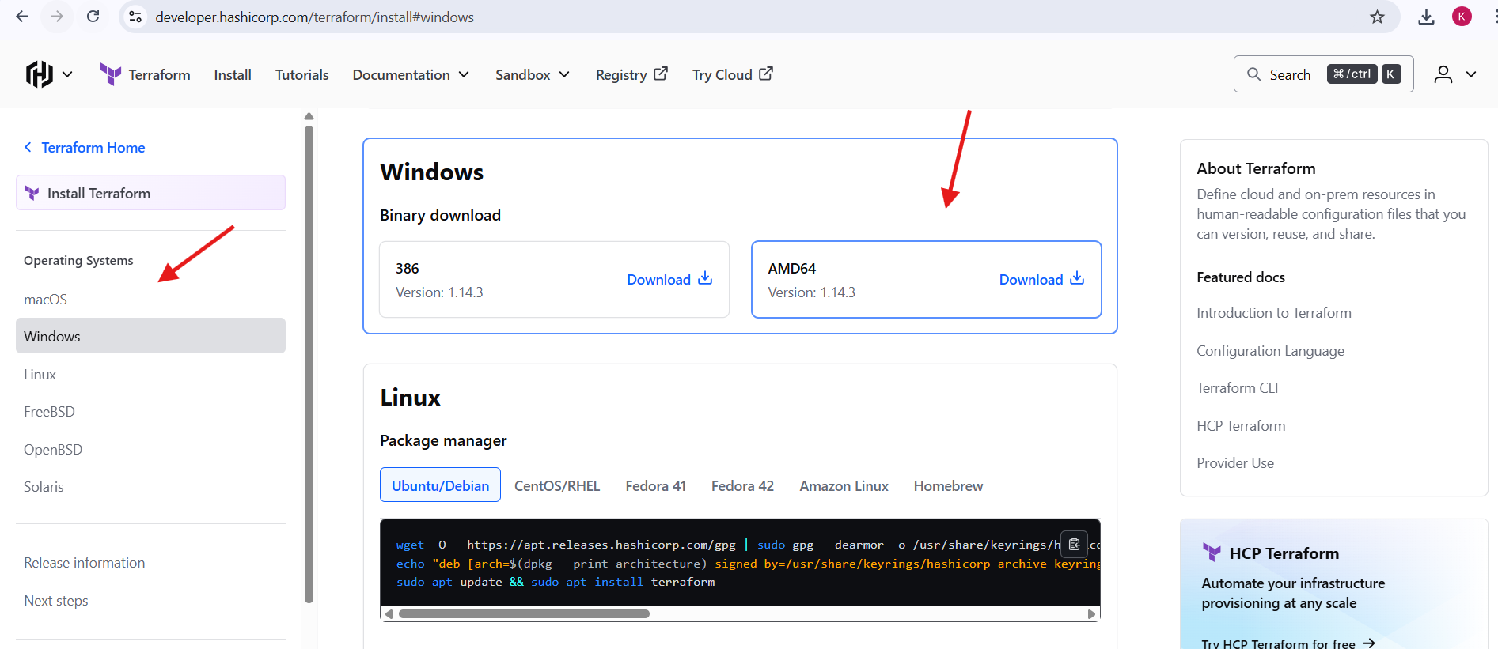
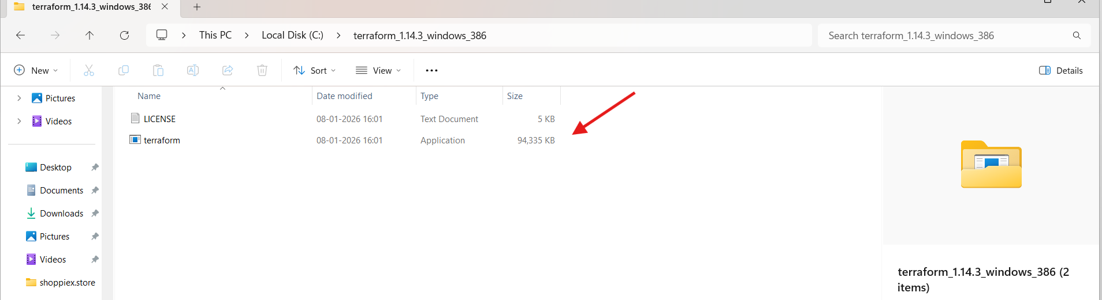
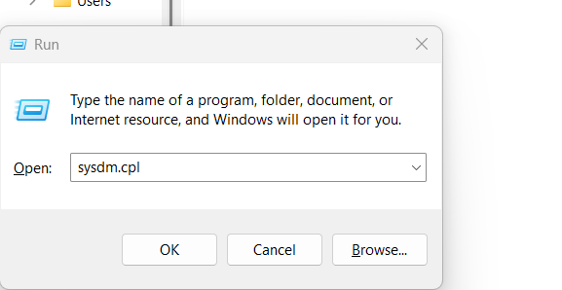
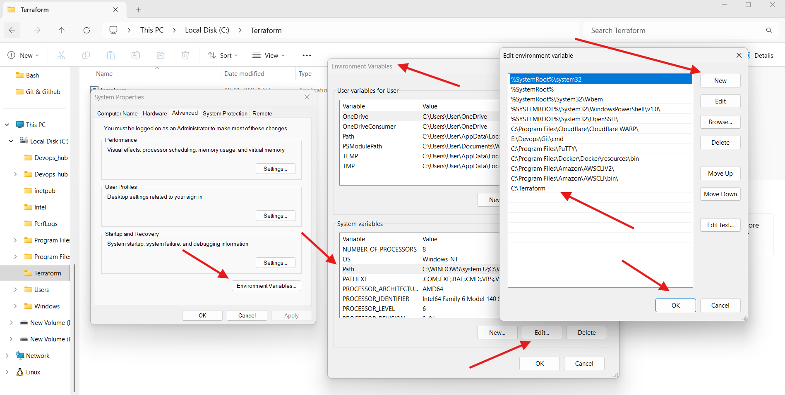
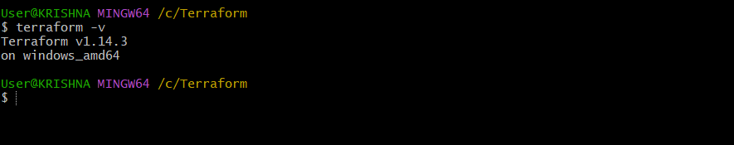
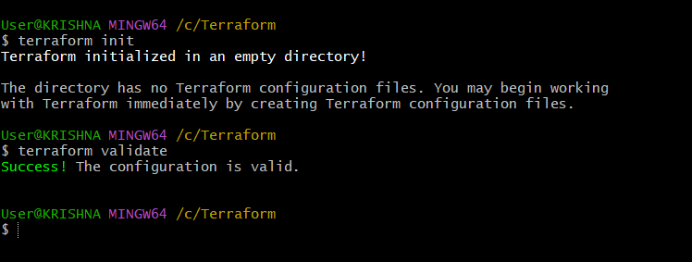
Validation Steps
- terraform -v confirms successful installation
- terraform init initializes Terraform working directory
- terraform validate confirms Terraform setup is correct
Conclusion
Terraform was successfully installed on Windows, added to system PATH, and verified using basic Terraform commands. The environment is now ready for writing and executing Terraform configuration files and integrating Terraform with CI/CD tools like Jenkins.

2. Execute all the templates shown in video.
Task Title
Execute Basic Terraform Templates Using VS Code on Windows shown in video
Objective
To create, execute, and validate basic Terraform templates using the local provider, and understand Terraform lifecycle commands (init, plan, apply) through hands-on execution.

Prerequisites
- Terraform installed and added to PATH
- Visual Studio Code installed
- HashiCorp Terraform VS Code extension installed
- Basic knowledge of command line
- Windows OS
Steps Performed:
Step 1: Create Project Folder
- On Desktop, create a folder named:
- Terraform basic
- This folder will act as the Terraform working directory.
Step 2: Open Folder in VS Code
- Right-click on Terraform basic folder
- Select Open with Code
- VS Code opens with an empty workspace
Step 3: Install Terraform Extension
- Click on Extensions icon in VS Code
- Search for:
- HashiCorp Terraform
- Click Install
- Terraform syntax highlighting and autocomplete are enabled
Step 4: Create Terraform Configuration File
- Click New File
- Name the file:
- main.tf
Step 5: Write Initial Terraform Template
Add the following code to main.tf:
resource "local_file" "my_pet" {
filename = "pets.txt"
}
Step 6: Open Integrated Terminal
- Go to Terminal → New Terminal
- Ensure the terminal path points to:
- Terraform basic
Step 7: Initialize Terraform
Run the command:
terraform init
Result:
- .terraform directory created
- Provider plugins downloaded
- Terraform initialized successfully
Step 8: Update Terraform Template
Modify main.tf as shown in the video:
terraform {
}

provider "local" {
}

resource "local_file" "my_pet" {
filename = "pets.txt"
content = "I hate pets!"
}
Step 9: Execute Terraform Apply
Run:
terraform apply
- Review execution plan
- Type yes when prompted
Result:
- pets.txt file created
- Terraform state file generated (terraform.tfstate)
Step 10: Modify Existing Template
Update the content in main.tf:
resource "local_file" "my_pet" {
filename = "pets.txt"
content = "I love pets!"
}
Step 11: Execute Terraform Plan
Run:
terraform plan
Result:
- Terraform detects change
- Shows resource replacement due to content modification
Step 12: Apply Updated Configuration
Run:
terraform apply
- Confirm with yes
Result:
- pets.txt updated
- State file updated
- Backup state file created (terraform.tfstate.backup)

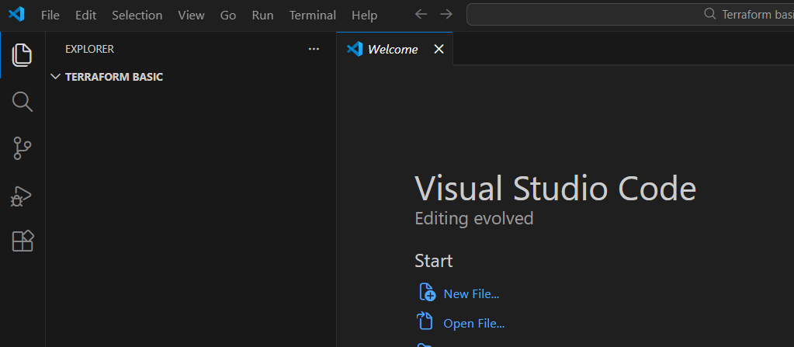
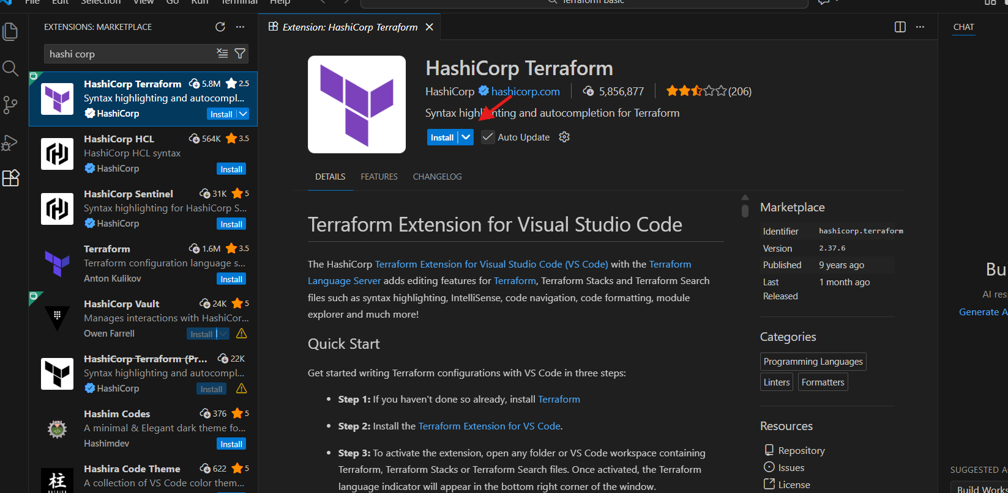
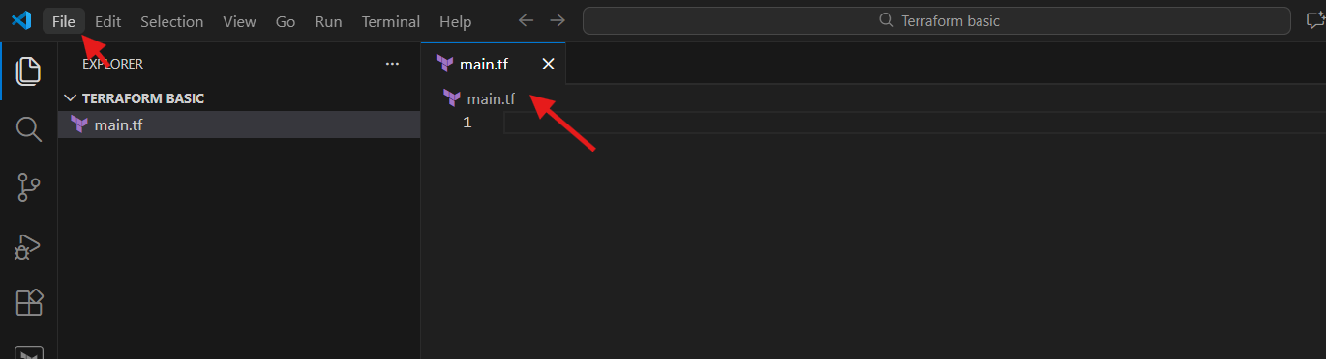
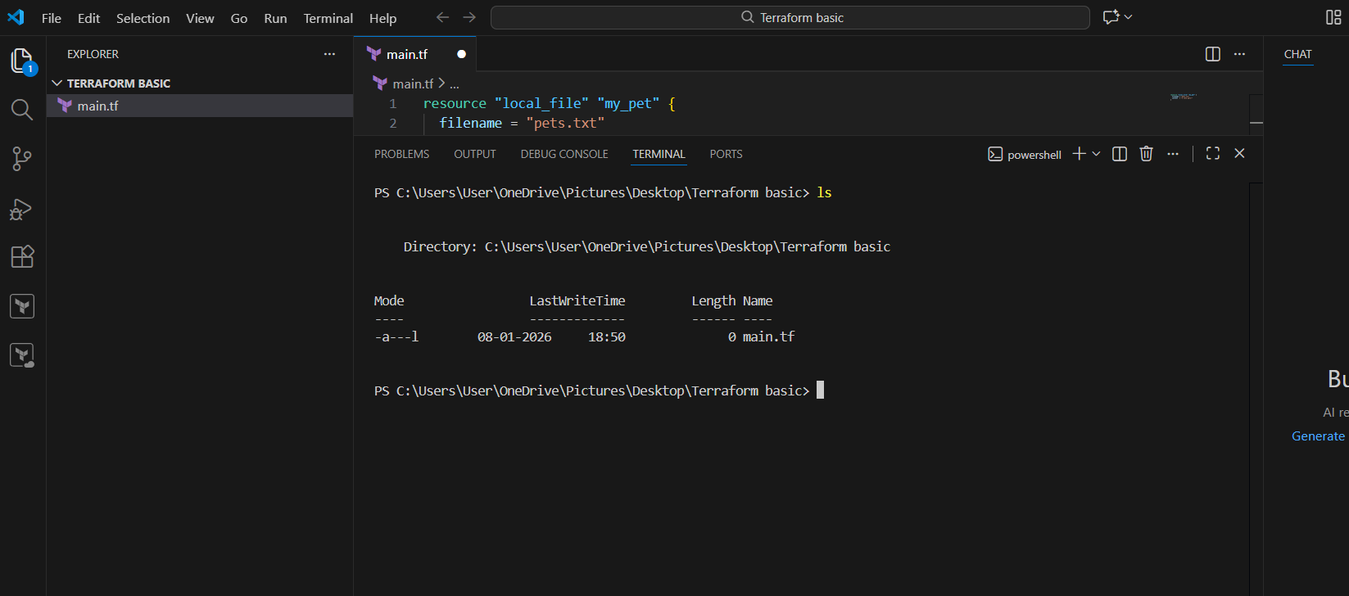
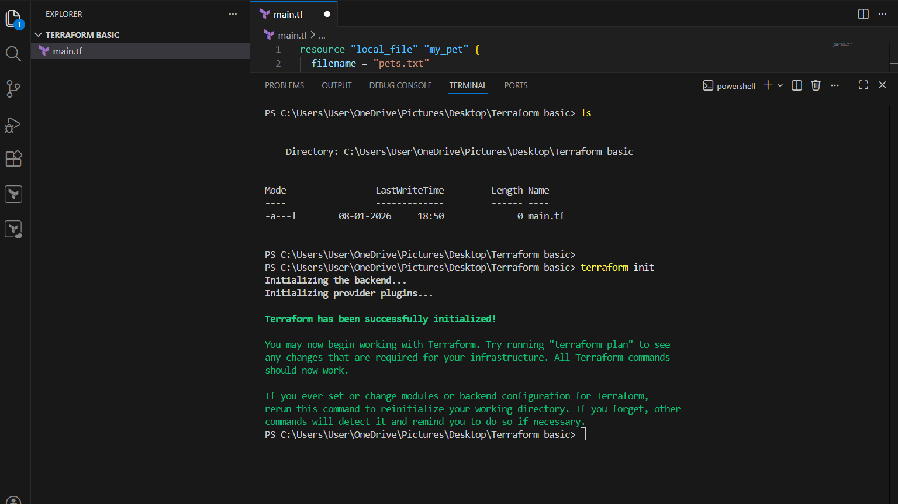
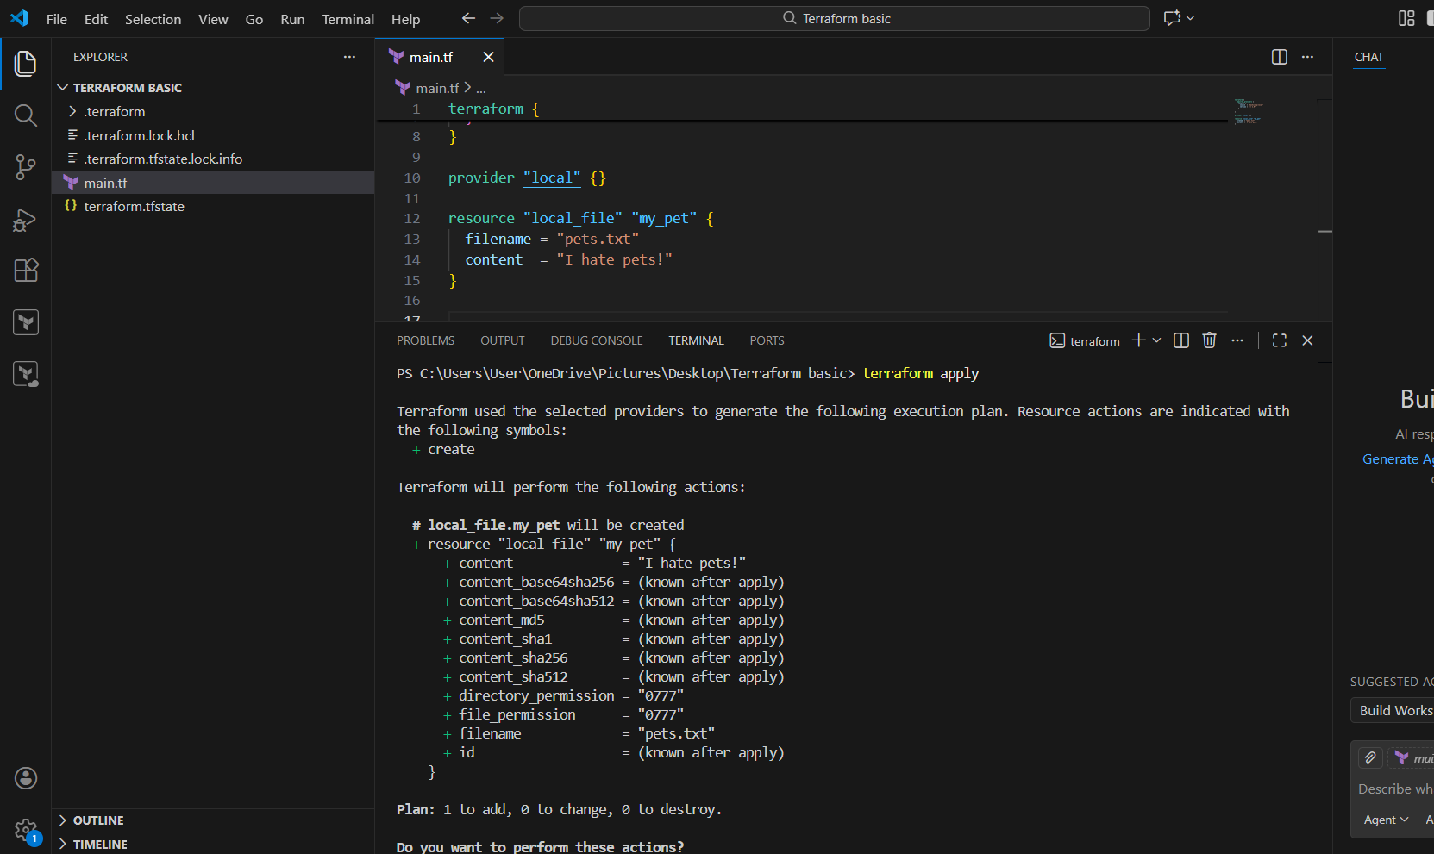
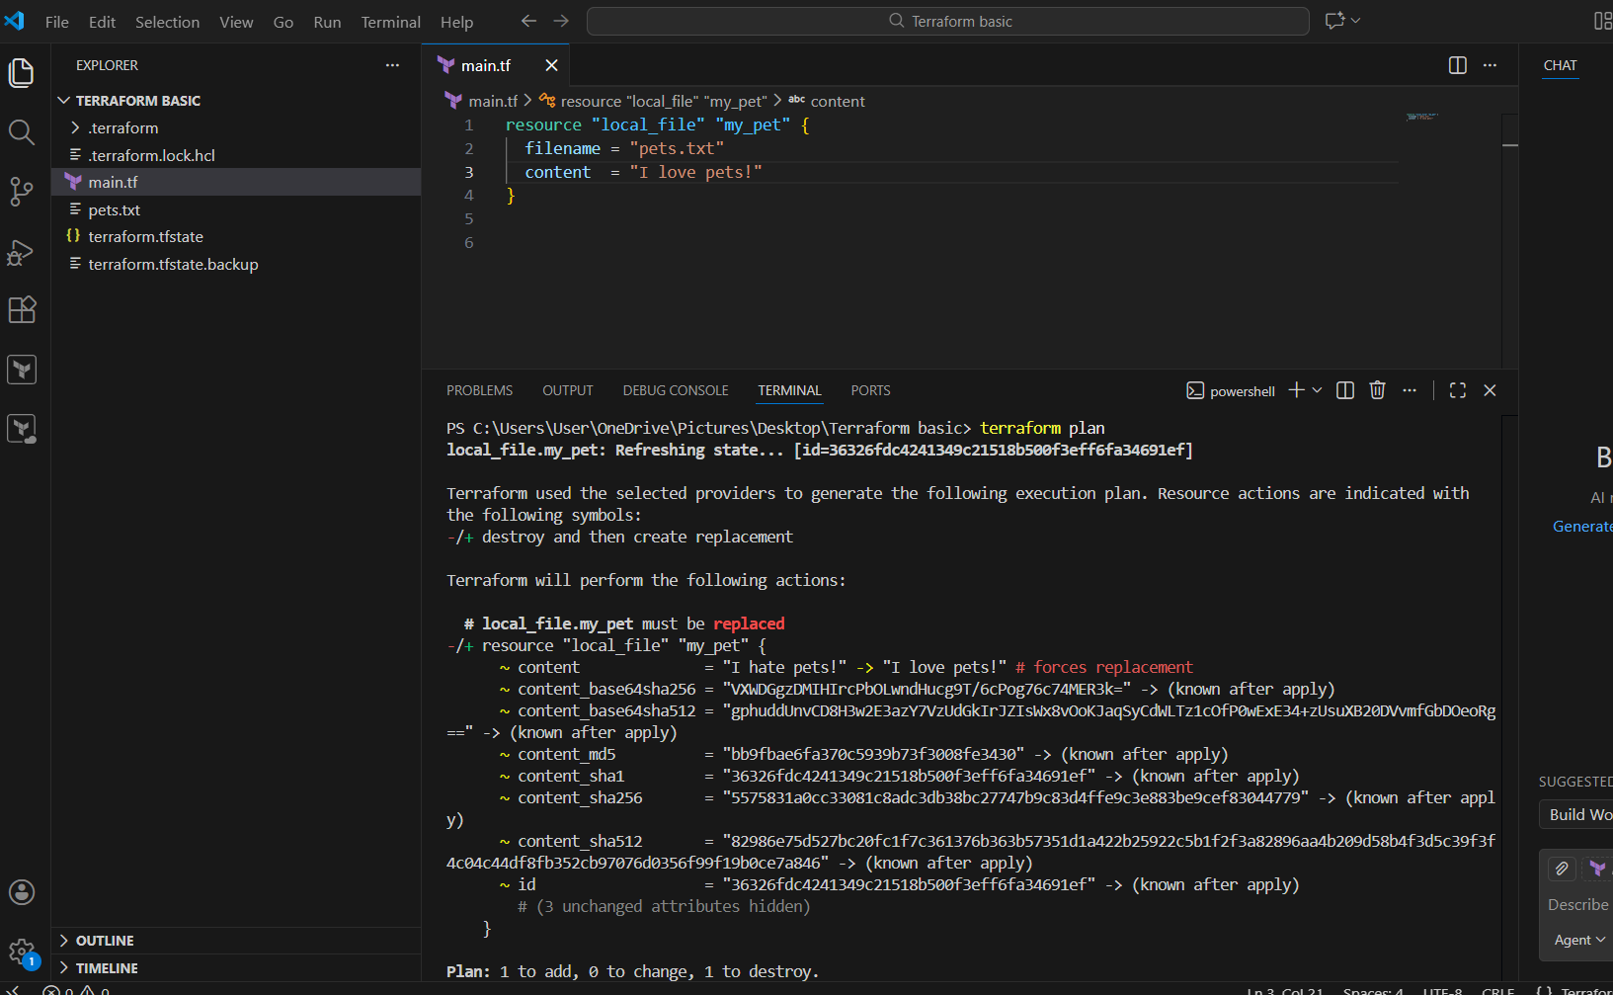
Validation Steps
- terraform init → Successful initialization
- terraform plan → Shows correct execution plan
- terraform apply → Resource created and updated
- pets.txt file present with updated content
- Terraform state files generated correctly
Conclusion
All Terraform templates shown in the video were successfully executed. Terraform lifecycle commands were validated, and resource creation, modification, and state management were demonstrated using a basic local provider setup. The task confirms a complete understanding of Terraform basics and execution flow.

3.Note down below points, Terraform Init, Terraform Plan, Terraform Apply, Terraform Provider.
Terraform Commands – Notes
Terraform Init
Definition:
Terraform Init is the first command executed in a Terraform project. It initializes the Terraform working directory.
Purpose:
- Downloads required provider plugins
- Initializes the backend configuration
- Creates the. terraform directory
- Prepares Terraform to run other commands
Command:
terraform init
Output Example:
Terraform has been successfully initialized!

Terraform Plan
Definition:
Terraform Plan is used to preview the changes that Terraform will make to the infrastructure.
Purpose:
- Shows what resources will be created, updated, or destroyed
- Compares Terraform configuration files with the current state
- Helps avoid accidental changes
Command:
terraform plan
Symbols Used:
- + Resource will be created
- ~ Resource will be modified
- - Resource will be destroyed

Terraform Apply
Definition:
Terraform Apply executes the changes required to reach the desired state of the infrastructure.
Purpose:
- Creates or updates resources
- Applies changes shown in Terraform Plan
- Updates the Terraform state file
Command:
terraform apply
Confirmation Prompt:
Do you want to perform these actions? yes

Terraform Provider
Definition:
A Terraform Provider is a plugin that allows Terraform to interact with external platforms and services.
Purpose:
- Acts as a bridge between Terraform and infrastructure platforms
- Defines how resources are created, updated, and deleted
Example Provider (Local):
provider "local" {
}

Task Title
Integrate a Sample Terraform Template in Jenkins
Objective
To install and configure Terraform in Jenkins, integrate Terraform code from a GitHub repository, and execute Terraform lifecycle commands (terraform init, terraform plan, terraform apply) using a Jenkins pipeline.
Prerequisites
- Jenkins installed and running on Linux server
- Internet access on Jenkins server
- Git installed on Jenkins server
- GitHub repository with Terraform code
- Jenkins Pipeline plugin
- Terraform plugin for Jenkins
Step-by-Step Implementation
Step 1: Install Terraform Plugin
- Login to Jenkins Dashboard
- Go to Manage Jenkins → Plugins
- Open Available plugins
- Search for Terraform
- Select the Terraform plugin
- Click Install
- Confirm plugin installation success
Step 2: Configure Terraform Tool
- Go to Manage Jenkins → Tools
- Scroll down to Terraform section
- Click Add Terraform
- Enter name:
- Terraform
- Enable Install automatically
- Select version:
- Terraform 1.5.x linux_amd64
- Click Save
Step 3: Create Terraform GitHub Repository
- Created a GitHub repository named:
- terraform-jenkins
- Added file main.tf with the following content:
- provider "local" {
- }

- resource "local_file" "sample_file" {
- filename = "jenkins-terraform.txt"
- content = "Terraform integrated with Jenkins"
- }
- Committed and pushed code to the main branch
Step 4: Create Jenkins Pipeline Job
- Open Jenkins Dashboard
- Click New Item
- Enter job name:
- Terraform Jenkins
- Select Pipeline
- Click OK

Step 5: Configure Pipeline Script
- In Pipeline section, select Pipeline script
- Entered the following code:
pipeline {
agent any

tools {
terraform 'Terraform'
}

stages {
stage('Git Clone') {
steps {
git branch: 'main',
url: 'https://github.com/krishnav7090/terraform-jenkins.git'
}
}

stage('Terraform Init') {
steps {
sh 'terraform init'
}
}

stage('Terraform Plan') {
steps {
sh 'terraform plan'
}
}

stage('Terraform Apply') {
steps {
sh 'terraform apply -auto-approve'
}
}
}
}

- Enable Use Groovy Sandbox
- Click Save
Step 6: Execute the Pipeline
- Click Build Now
- Jenkins installs Terraform automatically
- Git repository is cloned successfully
- Terraform Init executes successfully
- Terraform Plan executes successfully
- Terraform Apply creates the resource
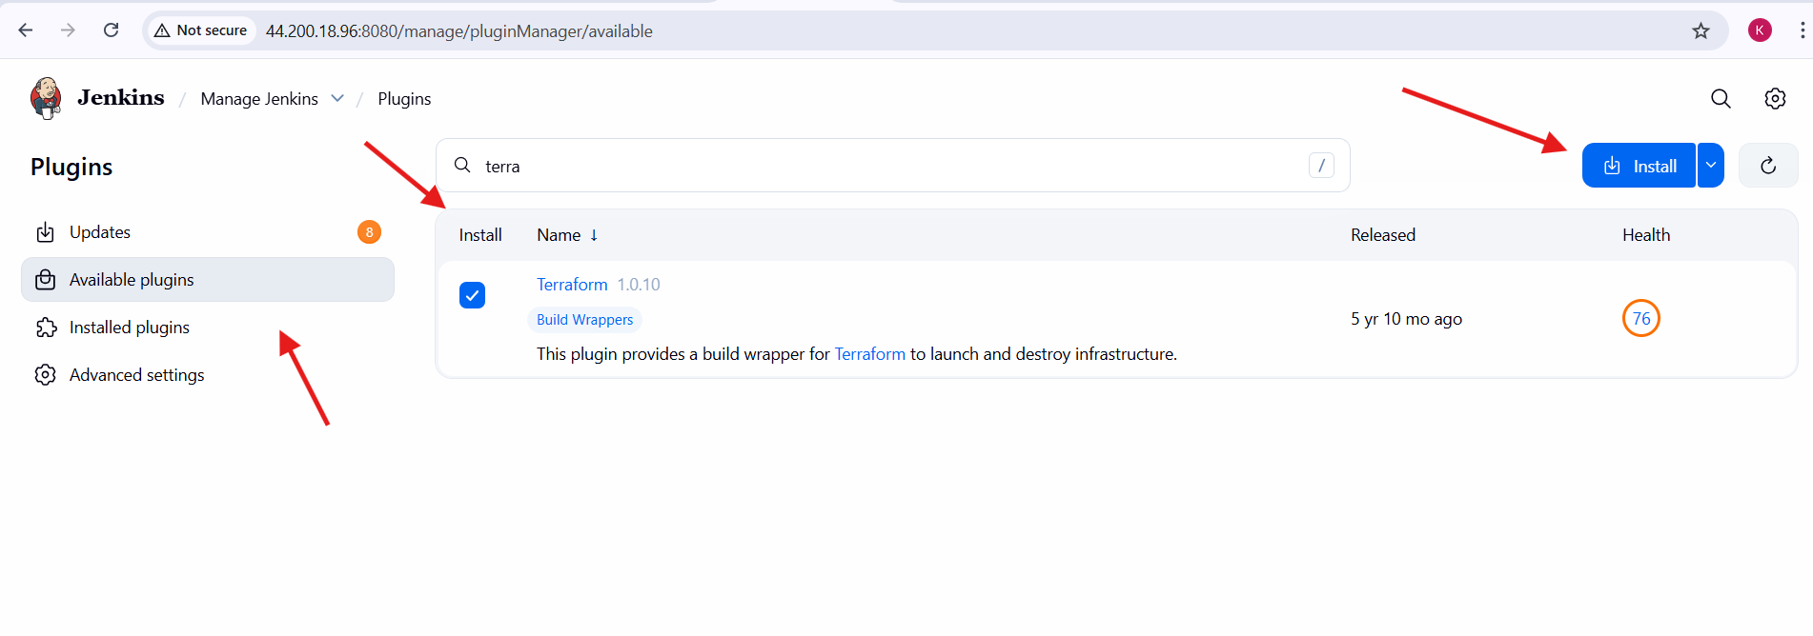
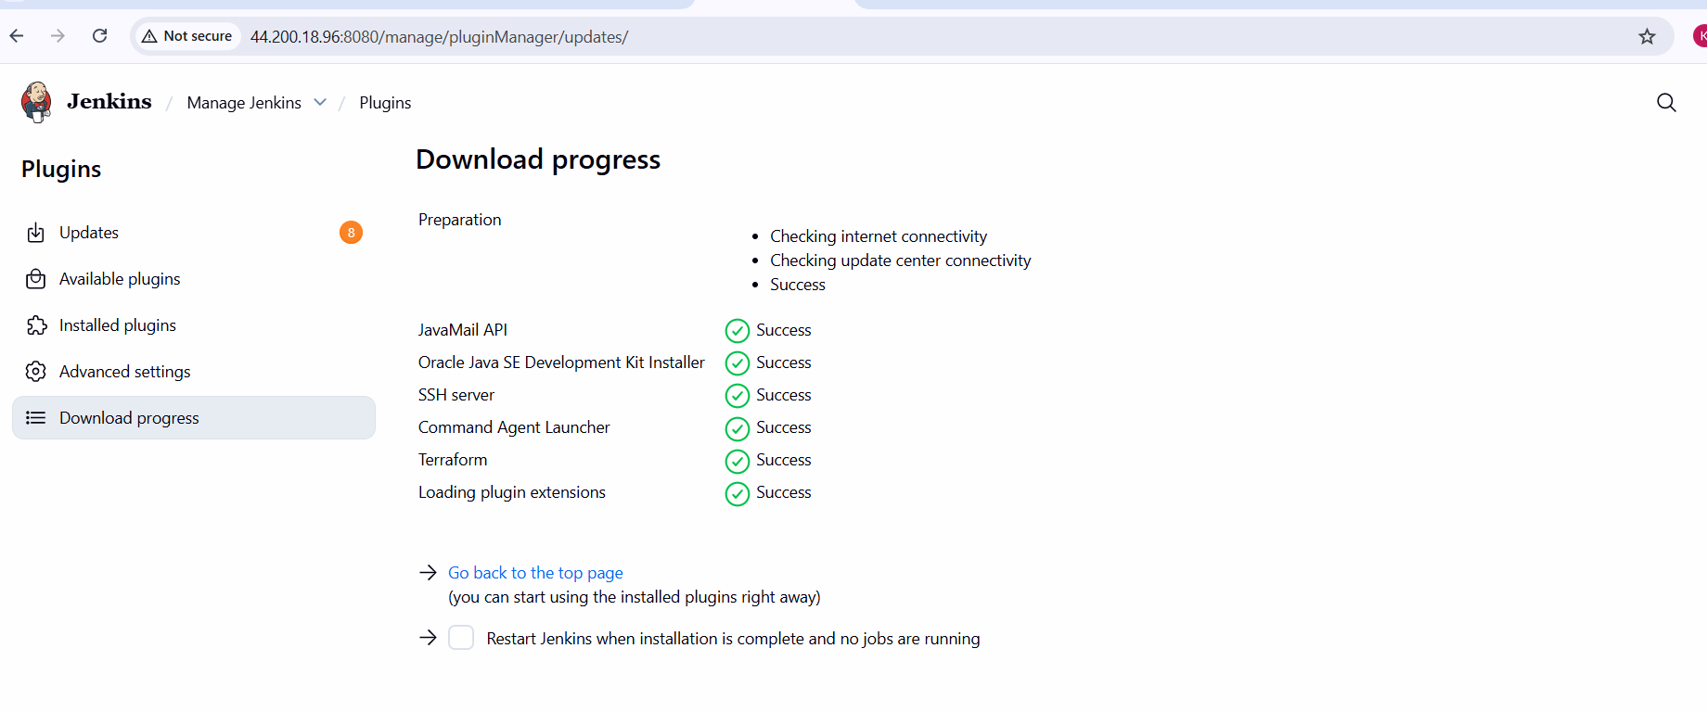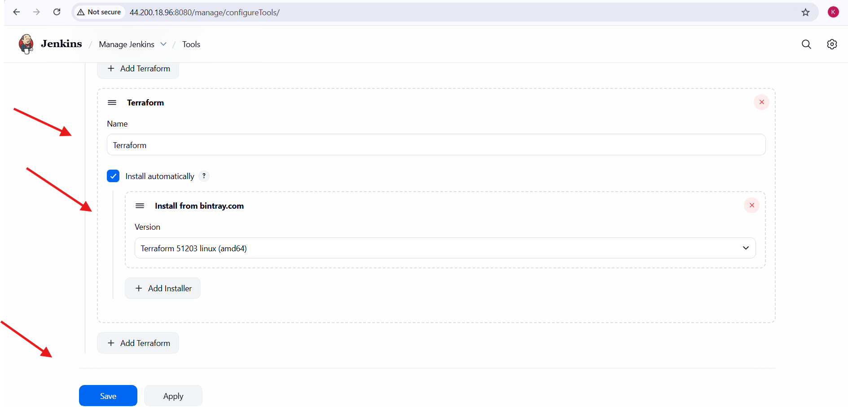

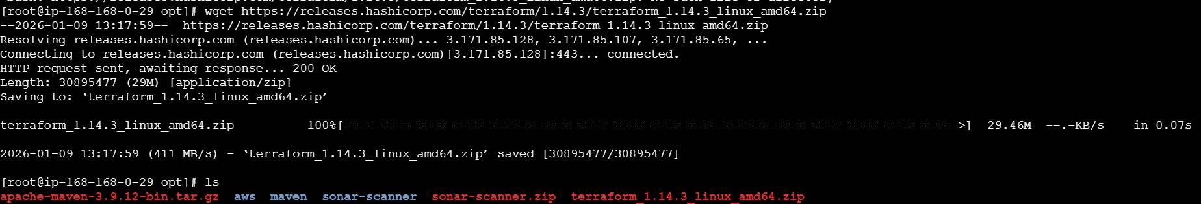
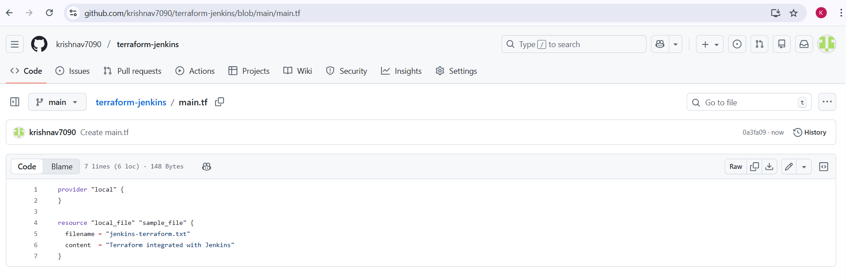
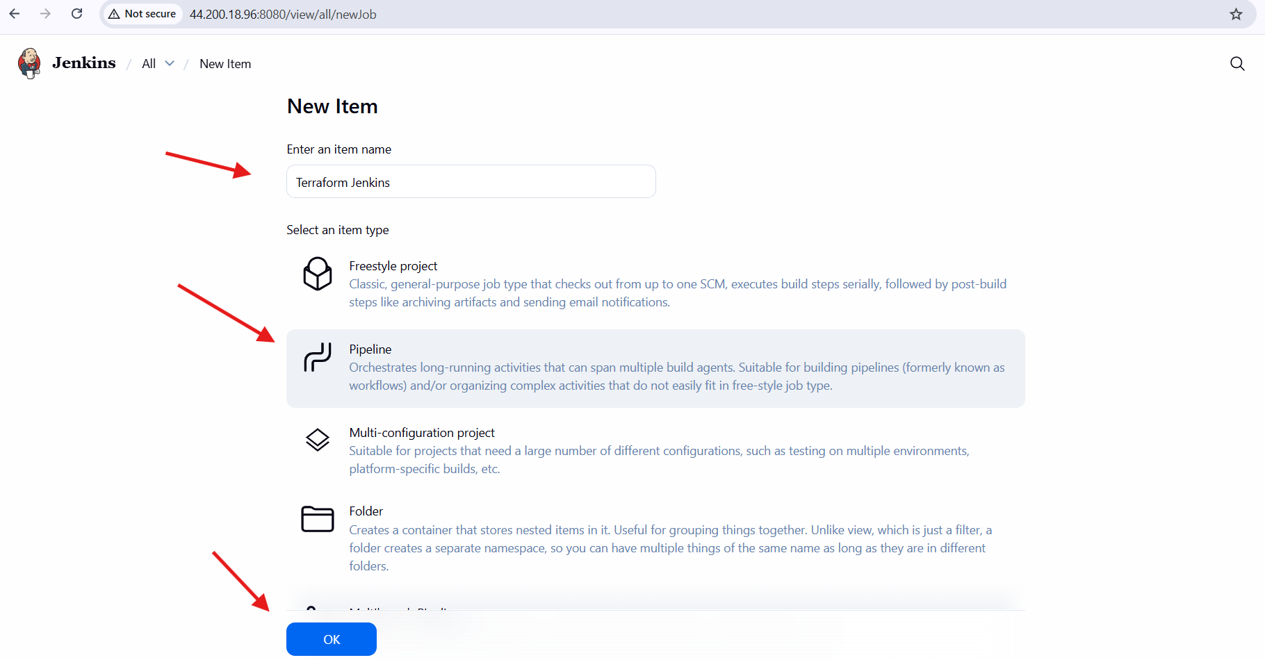
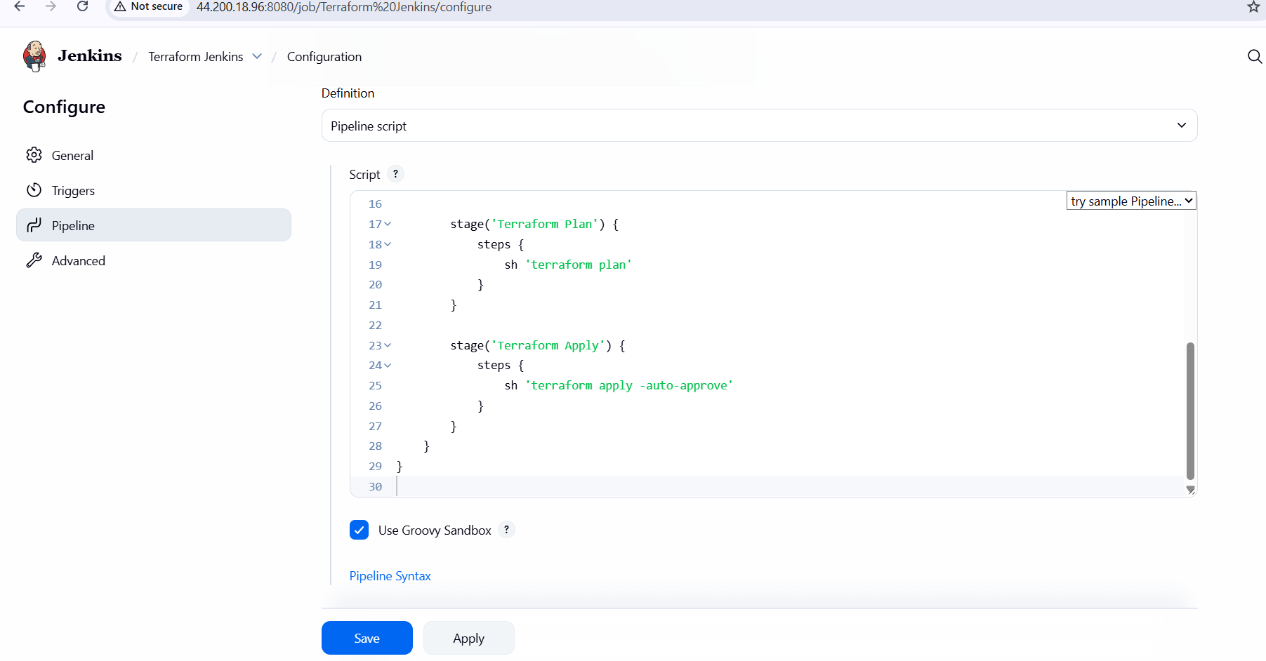
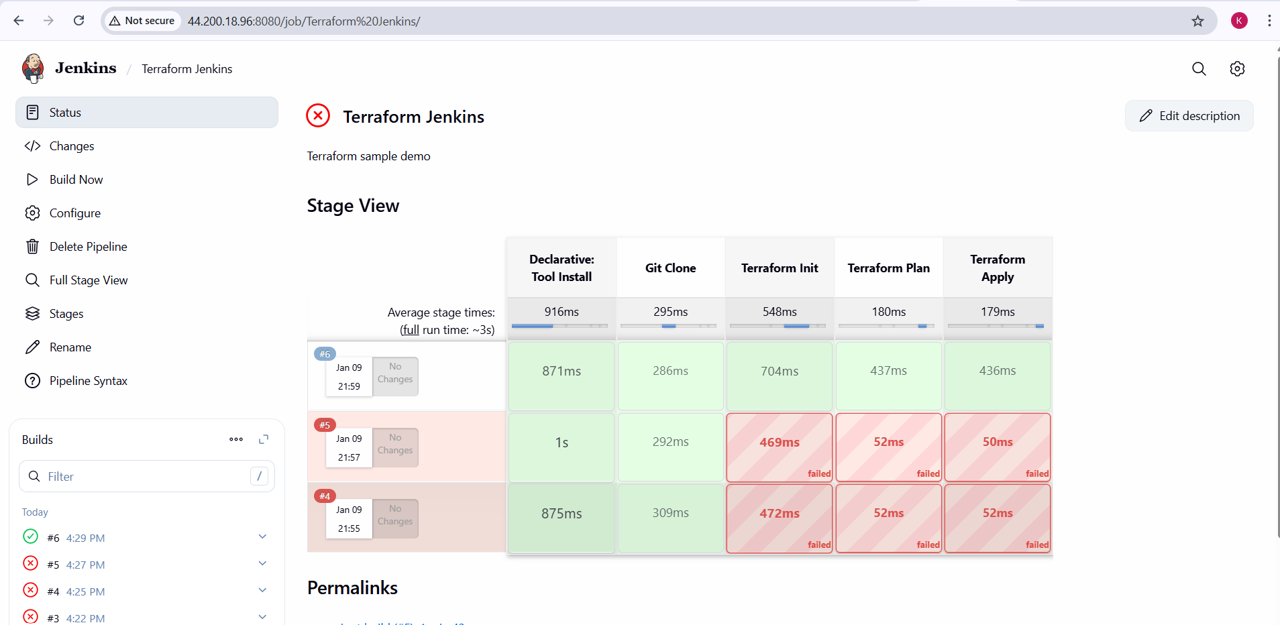

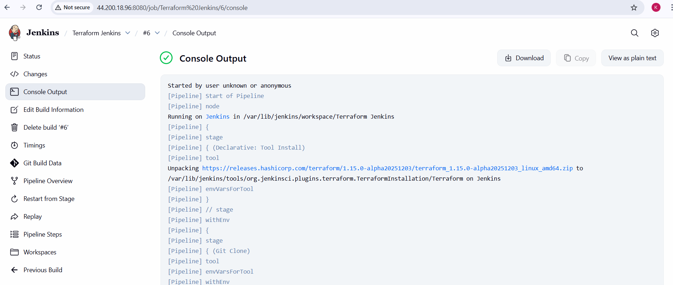
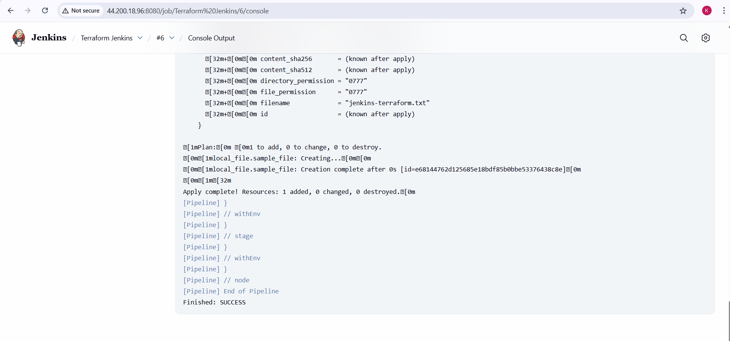

Validation Steps
- Jenkins console output shows:
- Terraform has been successfully initialized!
- Apply complete! Resources: 1 added, 0 changed, 0 destroyed.
- Finished: SUCCESS
- File jenkins-terraform.txt is created in Jenkins workspace
- Jenkins Stage View shows all stages in green
Conclusion
Terraform was successfully integrated with Jenkins using the Terraform plugin and Global Tool Configuration. The Jenkins pipeline executed all Terraform lifecycle commands (init, plan, apply) successfully, demonstrating Infrastructure as Code automation through CI/CD.

Overall Task Conclusion
In this task, Terraform was successfully installed and verified on the local system. All Terraform templates demonstrated in the video were executed using standard Terraform lifecycle commands. Core Terraform concepts such as initialization, planning, applying changes, and provider usage were clearly understood and implemented. Finally, Terraform was integrated with Jenkins using a pipeline job, enabling automated execution of Terraform commands. This task demonstrates effective use of Infrastructure as Code (IaC) and CI/CD practices for infrastructure automation.

